
Global Information System Ltd.


Proudly Presents

GIS Vehicle Rental System
Work Faster, Work Smarter.



GIS (now at version 3.0) is a flexible and scalable vehicle rental business management solution that empowers you to make important business decisions and deliver outstanding customer service and with greater confidence.

As the first Rich Internet Application developed for the vehicle rental industry, GIS features a highly responsive and interactive interface in a web browser with automatically loaded features and updates.

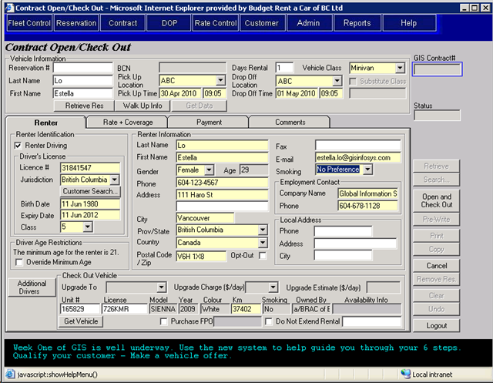
Opening a Contract: The use of tabs improves navigation and work flow.
Increases Operational Efficiency.

The basic building block for success in your vehicle rental business is customer satisfaction. No customer likes to wait in line or wait for vehicles to be ready. With GIS’ ease of use and improved fleet maintenance module, you can quickly retrieve repeat renters’ information, open a new contract and ensure that you have the vehicles your customers want. You will also have more time to sell your daily extras and coverage, ultimately maximizing your profits. GIS also supports the use of handheld devices (which utilizes WIFI) to speed up check-ins.

Not only does GIS help you manage your car rentals, it also helps you manage your entire fleet’s life cycle. From purchase to invoicing and registration to branch allocation, from rental/lease to maintenance and damage to sale/buyback, GIS tracks every stage perfectly. It even handles amortization and automates tedious accounting for you!

Long hours spent on paperwork and data entries are dramatically reduced, leaving you more time and a peace of mind to focus on improving business strategies and growing your business.
Provides Better Insight into Your Business.

Your business changes quickly. Simply tracking and storing information is not enough, GIS turns data into reports and analytics, giving you greater visibility into fleet control, trends and customers to make smarter decisions and maximize your business success with confidence.

You can also seek quantitative and qualitative feedback from GIS to track your employees’ and location’s performance and productivity. This will allow you to design an effective incremental sales program to capture the potential revenue from all possible ancillary items that can be missed otherwise. This will generate more revenue for your company, happy and motivated employees will keep customers happy, translating into a successful business.

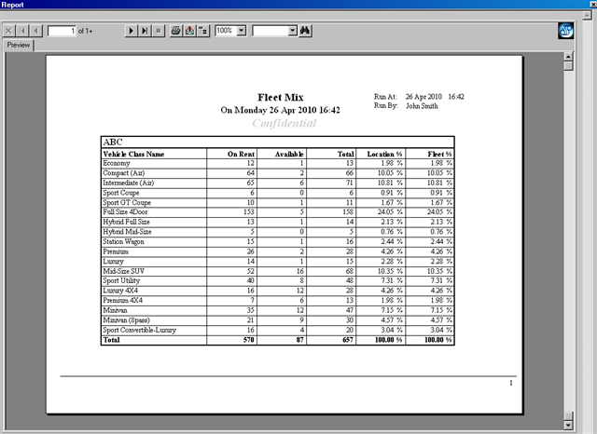
Real-time Fleet Monitoring: Helps you better manage and move your vehicles.
Enhances Flexibility and Security.

GIS’ role-based user experience allows you to customize screens for different employees so that they only have access to information/processes directly relevant to their jobs, helping them to focus on their jobs.

With the integration of the latest chip and pin technology into GIS, you can proudly protect your customers and your business from fraud.

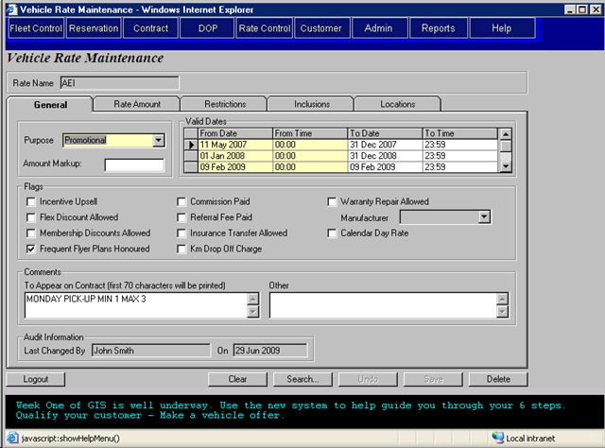
Setting/Changing Rates: This screen is only accessible by rates personnel.
Meets Your Needs for Today and Tomorrow.

GIS is a highly adaptable system which requires very little training time. Our staffs are only a phone call away to assist you with any setup and product support or help you master the system. You can leverage your existing IT assets by integrating GIS with your favorite accounting software and connecting it to a wide range of hardware such as printers, PIN pads and handheld devices.

Our development team constantly injects new features and reports into GIS to provide you with a more efficient solution for your business. The nature of GIS allows it to download any new features and upgrades to your computers automatically so that you can start working instantly!

What Our Customers Say.

“We’ve accomplished so much since GIS came into our business ten years ago! GIS has helped us managed our fleet, rentals and revenue across all our branches and even among our foreign partners. Our locations in downtown and airport have such high demand in car rentals but GIS’ easy to use interface and processing speed significantly cuts down our customers’ waiting time. Our top CSR can even open a contract in just one minute!”
-- Harry Toor (Operations Manager, Budget Rent-a-Car of B.C. Ltd.)

“We just wanted to send you a quick note to thank you for all your hard work and effort in helping to get Victoria converted over to the new fleet accounting system in GIS. GIS has significantly improved our accounting and control process over our vehicles and is certainly a major enhancement over our old vehicle ledger. Again, thank you for your effort and at times patience with us. It has been a pleasure working with you on this.”
-- David Hunt (Controller, Budget Rent a Car of Victoria)

“Global InfoSys offered us all the help and guidance we needed to make the transition from our previous system to GIS seamless and painless. The short training they provided us at the start was so useful and our business has turned out so much better than expected. Excellent work overall and we look forward to our continued relationship with Global InfoSys.”
-- William Ung (CEO, Phelps Leasing Ltd.)

Global Information System Ltd.

We are here to help you.
Visit us at www.gisinfosys.com or call 778-889-1750.

206 – 7080 River Road, Richmond B.C. V6X 1X5
© 2010 Global Information System Ltd. All rights reserved.

GIS System Introduction

Features || Sample Screens || Sample Reports

Feature Presentation.

GIS encompasses a wide range of functionalities to meet the growing demands of the vehicle rental industry.

Reservations & Rentals
- Checks rate and vehicle availability in real-time
- Delivers online reservations to GIS
- Allows you to modify or cancel reservation
- Auto-calculates taxes and location surcharges
- Handles tax exempt rentals
- Stores customer information and preference for future fast processing
- Tracks undesirable customers
- Identifies unlimited additional drivers
- Allows for sale of accessories and coverage
- Able to process one-way or foreign rentals and split revenue with other branches
- Provides vehicle exchange/upgrade during rental
- Query tool allows searching by multiple criteria
- Allows you to adjust and void rental agreement (even after contract is closed)
- Utilizes an EMV chip-based payment card system
- Supports credit/debit card and cash
- Allows multiple split billing among renter, insurance company and direct bill customers
- Unlimited internal/ printed notes for each contract

Fleet Operations, Accounting & Maintenance
- Handles any addition, change and deletion in vehicle model year, vehicle classes and fleet
- User-defined minimum age for driver
- Query tool supports single/multi-vehicle search
- Allows you to update vehicle status, record vehicle condition/vehicle support incidents and restrict location rentals
- Stores detailed vehicle purchase, depreciation, loan, lease and sales information
- Creates loan, vehicle, lease amortization schedules
- Estimates fleet’s book value based on its depreciation, inactivity and mileage
- Retains detailed vehicle rental and damage history
- Tracks non-revenue movement of vehicles

Rate Control
- Supports unlimited rate types: hourly, daily, weekly, monthly, package, seasonal, corporate/ tour and calendar day rates
- User-defined rate rules, time and grace periods
- Allows you to include sales accessories, taxes, fuel and specific fees in rate
- Identifies restrictions and auto-applies violation rates

Corporate Customer Processing
- Stores company profiles and referral information
- Assigns specific rates to corporate accounts
- Allows you to specify/override driver’s minimum age

Auto-Generated Accounting Entries
- Eliminates data duplication and re-entry
- Carries split billing smoothly to your accounting entries
- Generates accounting entries for daily rentals, inter-branch and fleet

Location Control
- Links contact information of each location to contract
- Customizable fees/drop off charges for different locations
- Supports location-based authorization or location-based restriction of vehicle classes
- Allows a real-time broadcast message for every location

Violation Ticket Management
- Stores detailed information of the violation such as responsible renter, amount, date, time and location
- Processes ticket payment in the contract while recording violation in the system
- Exports rental and ticket information to a letter

Frequent Flyer Point & Voucher Processing
- Supports voucher codes and all Air Miles promotions
- Adjustable reward miles after contract is closed

Security & Reliability
- Grants user permission by level of authority and by system functionalities
- Provides multi-level high security control with supervisor override capability
- Allows you to monitor user activities in real-time
- Stores your valuable data securely in servers with firewall protection and daily backups
- Delivers a secure and certified interface for debit and credit card processing

Analysis & Reports
- Contains accounting interfaces so that data can be exported to any accounting software
- Fully exportable to Microsoft Excel for chart/graph creation and analysis
- Built-in employee incentive report
- Over 60 reports to provide better management, fleet planning and to increase revenue

Sample Screen for Contract Open

The Contract Open screen allows you to select rental locations and pickup/drop off times, record rental information and sell rental coverage/accessories professionally, giving you a comfortable workflow with more control. You can also retrieve repeat renter’s information by searching with the driver’s license number or the customer search tool.

A contract can be pre-written for the customer if the vehicle is not ready.

You can sell fuel option or upgrade the vehicle here.

Retrieve renter’s information quickly by entering the driver’s license #.

Sample Screen for Vehicle Inventory

The Vehicle Inventory screen lists every single detail you need to know about your vehicles. Whenever a vehicle is rented out, returned, moved or changed in any way, the system will automatically record the event.

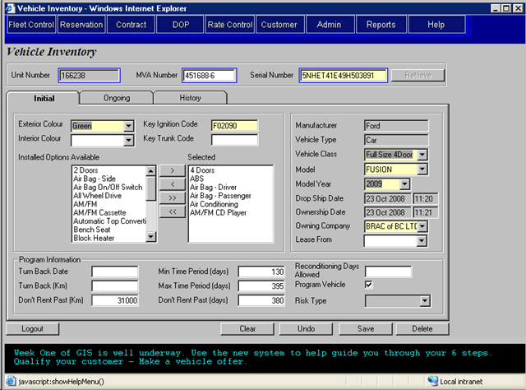
All rentals/movements as well as changes in vehicle status and conditions are recorded here.

The system will automatically restrict rentals/movements of this vehicle with reference to all the information here.
(Note: A program vehicle is a re-purchasable vehicle which can be turned back to the dealer or manufacturer after a certain accumulated mileage or after a specific number of days.)

Sample Screen for Location Control

In the Location Maintenance screen, you can specify the vehicle classes available for rent at this location and individually assign rates for each of these vehicle classes. You are also able to define rates for walk up and reservation, contact information, specific fees (such as fuel price, location fee, vehicle licence fee etc.), drop off location and other miscellaneous information for each location.

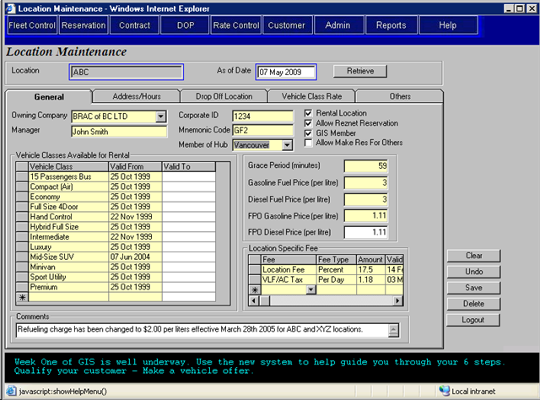
This sub screen allows you to define walk up and reservation rates for each vehicle class at this location.

You can select the vehicle classes available for rent at this location.

Sample Screen for Reservation

You can instantly process/refund a deposit payment (manually or via a PIN pad) through the Reservations screen with the money going straight into your bank account.

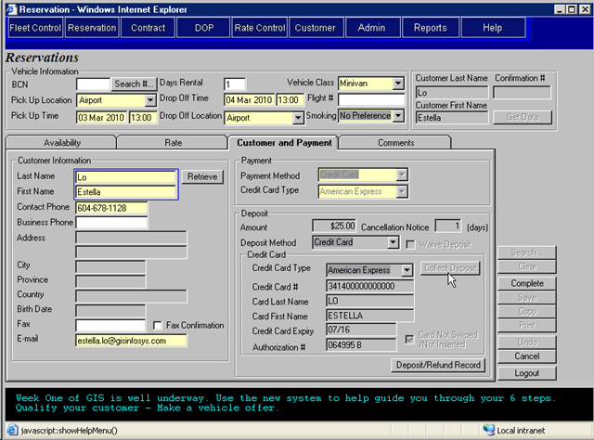
An authorization number will be generated automatically once you collect deposit.

You can also waive a deposit, if necessary.

Sample Screen for Fleet Control

The Fleet Master screen is an extension of the Vehicle Inventory screen with the addition of an accounting tab that records all each of your vehicle’s purchase/loan/lease/sales data, amortization schedules and current book value.

The Month End Processing screen allows you to generate monthly amortization schedules for all your in-service vehicles in Fleet Master with just one click.

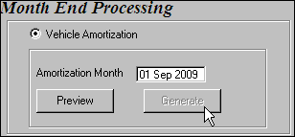

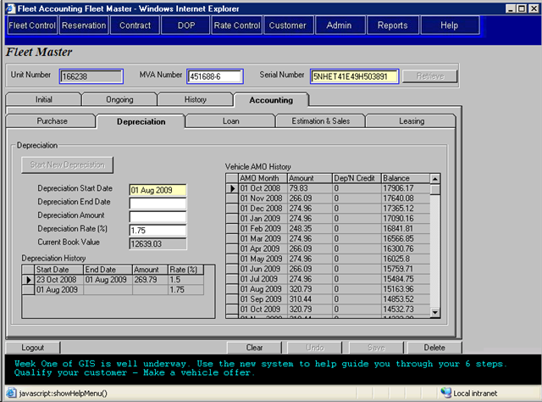
You can set either a flat or percentage depreciation rate.
Monthly amortization can be created within one click.
The value of your vehicle as of the current day. amortization can be created within one click.

